## 背景

算力网络部分：Iaas侧主要需要给富通CMP梳理SDN相关的业务接口调用，主要需要梳理以下两块业务：

1. 获取标识网络质量元素：获取敖飞平台用到的业务网（一般网络）和参数网、存储网（参数网和存储网应该是同一张网卡，需要用到ROCE无损网络）相关的网络指标元素，包括时延、抖动、丢包、带宽；
2. 获取sdn的网络拓扑，包含路由器、防火墙、安全设备、LB、交换机、服务器（服务器的拓扑SDN上可能没有，如果没有就需要在垫层实现，通过手动配置的方式提供服务器的拓扑）

## 接口梳理

###### 2.1查询网络链路质量监控接口

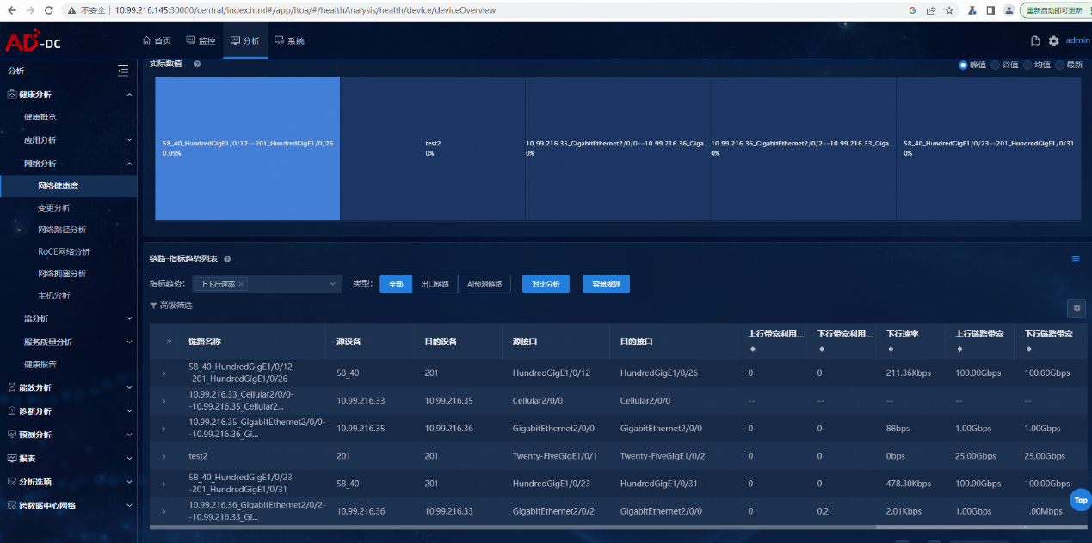

|  |  |  |  |  |  |  |  |
| --- | --- | --- | --- | --- | --- | --- | --- |
| 查询链路的指标信息列表 |  |  |  |  | | | |
| 接口描述 | 查询链路的指标信息列表 |  |  |  | | | |
| URL | /telemetry/getLinkTargetThresholdList |  |  |  | | | |
| 请求方式 | GET |  |  |  | | | |
| 请求类型 | application/json |  |  |  | | | |
| 返回类型 | application/json,text/plain;charset=utf-8 |  |  |  | | | |
| 参数名 | 数据类型 | 参数类型 | 是否必填 | 说明 | | | |
| 1.startTime | integer(int64) | query | Y | 起始时间 | | | |
| 2.endTime | integer(int64) | query | Y | 终止时间 | | | |
| 3.objectType | string | query | Y | 列表数据类型 | | | |
| 4.deviceName | string | query | Y | 设备名称 | | | |
| 5.linkName | string | query | Y | 链路名称 | | | |
| 6.searchName | string | query | Y | 设备名称(模糊查询) | | | |
| 7.searchLink | string | query | Y | 链路名称(模糊查询) | | | |
| 8.sort | boolean | query | Y | sort | | | |
| 9.sortType | string | query | Y | 排序方式 | | | |
| 10.sortColumn | string | query | Y | 排序列 | | | |
| 11.tag | string | query | Y | 时间标签 | | | |
| 12.pageNum | integer(int32) | query | Y | 页号 | | | |
| 13.pageSize | integer(int32) | query | Y | 页大小 | | | |
| 14.areaId | string | query | N | 区域ID | | | |
| 15.assetId | string | query | N | 设备ID | | | |
| 16.areaType | integer(int32) | query | N | 区域类型 | | | |
| 17.linkType | string | query | N | 链路类型，全部链路/出口链路 | | | |
| 状态码 | 描述 |  | 说明 |  | | | |
| 200 | OK |  |  |  | | | |
| 401 | Unauthorized |  |  |  | | | |
| 403 | Forbidden |  |  |  | | | |
| 404 | Not Found |  |  |  | | | |
| 返回属性名 | 类型 |  | 说明 |  | | | |
| 1.data | object |  |  |  | | | |
| 2.errorCode | integer(int32) |  |  |  | | | |
| 3.message | string |  |  |  | | | |
| 示例：<http://10.99.216.145:30000/DataCore/healthAnalysis/telemetry/getLinkTargetThresholdList?objectType=link&sort=true&sortColumn=&sortType=&tag=1d&pageNum=1&pageSize=15&areaId=&areaType=2&startTime=1698060185944&endTime=1698146585944&linkType=allLink> | | | | | | | |
| 请求参数 | startTime=0&endTime=0&objectType=string&deviceName=string&linkName=string&searchName=string&searchLink=string&sort=true&sortType=string&sortColumn=string&tag=string&pageNum=0&pageSize=0&areaId=string&assetId=string&areaType=0&linkType=string | | | |  |  |  |
| 返回值 | {      "data": {          "total": 5,          "columnList": [              {                  "unit": "%",                  "columnCn": "上行带宽利用率",                  "columnEn": "Uplink Usage",                  "columnKey": "useRatio1To2"              },              {                  "unit": "%",                  "columnCn": "下行带宽利用率",                  "columnEn": "Downlink Usage",                  "columnKey": "useRatio2To1"              },              {                  "unit": "bps",                  "columnCn": "下行速率",                  "columnEn": "Down Speed",                  "columnKey": "speed2To1"              },              {                  "unit": "Mbps",                  "columnCn": "上行链路带宽",                  "columnEn": "Uplink Link Band",                  "columnKey": "ifHighSpeed1"              },              {                  "unit": "Mbps",                  "columnCn": "下行链路带宽",                  "columnEn": "Downlink Link Band",                  "columnKey": "ifHighSpeed2"              },              {                  "unit": "ms",                  "columnCn": "负向抖动",                  "columnEn": "negAvgSd",                  "columnKey": "negAvgSd"              },              {                  "unit": "bps",                  "columnCn": "上行速率",                  "columnEn": "Up Speed",                  "columnKey": "speed1To2"              },              {                  "unit": "ms",                  "columnCn": "时延",                  "columnEn": "Latency",                  "columnKey": "avgRtt"              },              {                  "unit": "%",                  "columnCn": "丢包率",                  "columnEn": "Packet Loss Rate",                  "columnKey": "lossRatio"              },              {                  "unit": "ms",                  "columnCn": "正向抖动",                  "columnEn": "posAvgSd",                  "columnKey": "posAvgSd"              }          ],          "objectList": [              {                  "speed2To1": 16,                  "speed1To2": 0,                  "ifDescr1": "GigabitEthernet2/0/0",                  "ifDescr2": "GigabitEthernet2/0/0",                  "assetName2": "10.99.216.36",                  "assetName1": "10.99.216.35",                  "predictLink": 0,                  "posAvgSd": "--",                  "avgRtt": "--",                  "lossRatio": "--",                  "isAlarm": false,                  "negAvgSd": "--",                  "ifHighSpeed2": 1000,                  "name": "10.99.216.35_GigabitEthernet2/0/0--10.99.216.36_GigabitEthernet2/0/0",                  "ifHighSpeed1": 1000,                  "id": "9e98c632-3d62-3c5a-b1d4-23b29059a6fe",                  "egressLink": 0,                  "useRatio1To2": 0.0,                  "useRatio2To1": 0.0              }          ]      },      "errorCode": 0,      "message": "success"  } | | | |  |  |  |

###### 2.2查询网络设备拓扑信息接口

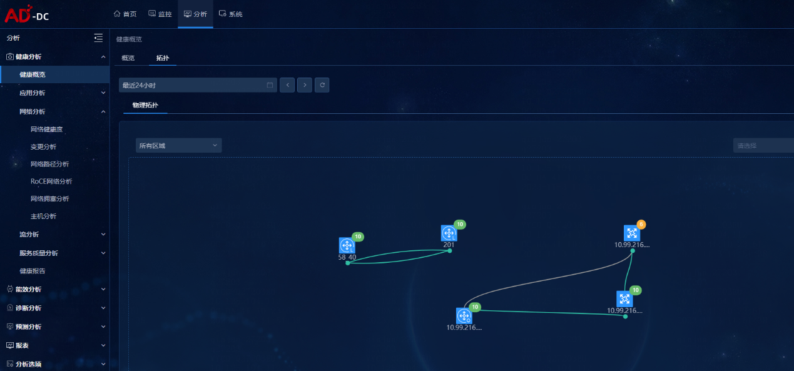

|  |  |  |  |  |
| --- | --- | --- | --- | --- |
| 查询拓扑信息 |  |  |  |  |
| 接口描述 | 查询拓扑信息 |  |  |  |
| URL | /healthAnalysis/netTopo/getSeerEnginTopoInfo |  |  |  |
| 请求方式 | GET |  |  |  |
| 请求类型 |  |  |  |  |
| 返回类型 | application/json,text/plain;charset=utf-8 |  |  |  |
| 参数名 | 数据类型 | 参数类型 | 是否必填 | 说明 |
| 状态码 | 描述 |  | 说明 |  |
| 200 | Success |  |  |  |
| 401 | Unauthorized |  |  |  |
| 403 | Forbidden |  |  |  |
| 404 | Not Found |  |  |  |
| 返回属性名 | 类型 |  | 说明 |  |
| 示例 |  |  |  |  |
| 请求参数 | topoId=globalTopo  areaId= 区域ID  areaType=2 区域类型，0物理区域，1逻辑区域，2全部 |  |  |  |
| 返回值 | {      "result": {         "isCreated": true,         "linkNum": 1,//拓扑链路数量         "nodes": [{             "flag": "route",//设备类型的集合             "children": [{                "role": "",                "apLocationY": 500,                "apLocationX": 500,                "healthScore": 10,                "virtualPortCount": 0,                "firstTypeIdValue": "网络设备",                "assetId": "65074cb3-771d-38b1-b828-345583919287", //分析器设备ID                "client": "{\"assetId\":\"65074cb3-771d-38b1-b828-345583919287\",\"secondTypeIdValue\":\"路由器\",\"assetNetAddress\":\"10.99.216.36\",\"netElementType\":7}",                "model": "",                "apCount": 0,                "locationY": 244,                "onuCount": 0,                "firstTypeId": 2,                "secondTypeIdValue": "路由器", //设备类型                "locationX": 484,                "onuList": [],                "netElementType": 7,                "assetNetAddress": "10.99.216.36", //设备IP                "apIps": [],                "assetName": "10.99.216.36", //分析器设备名称                "apLowestHealthScore": 10,                "apList": [],                "softwareVersion": "Version 7.1.064, ESS 0821P02"             }, {                "role": "",                "apLocationY": 500,                "apLocationX": 500,                "healthScore": 1,                "virtualPortCount": 0,                "firstTypeIdValue": "网络设备",                "assetId": "6f9b2840-458a-3c76-8134-04b64eade7c1",                "client": "{\"assetId\":\"6f9b2840-458a-3c76-8134-04b64eade7c1\",\"secondTypeIdValue\":\"路由器\",\"assetNetAddress\":\"10.99.216.35\",\"netElementType\":7}",                "model": "",                "apCount": 0,                "locationY": 100,                "onuCount": 0,                "firstTypeId": 2,                "secondTypeIdValue": "路由器",                "locationX": 500,                "onuList": [],                "netElementType": 7,                "assetNetAddress": "10.99.216.35",                "apIps": [],                "assetName": "10.99.216.35",                "apLowestHealthScore": 10,                "apList": [],                "softwareVersion": "Version 7.1.064, ESS 6749L02"             }],             "index": 0         }, {             "flag": "spine",             "children": [],             "index": 1         }, {             "flag": "leaf",             "children": [],             "index": 2         }, {             "flag": "access",             "children": [],             "index": 3         }, {             "flag": "other", //其他设备             "children": [],             "index": 4         }, {             "flag": "transit",             "children": [],             "index": 5         }, {             "flag": "core",             "children": [],             "index": 6         }, {             "flag": "aggregation",             "children": [],             "index": 7         }, {             "flag": "border",             "children": [],             "index": 8         }],         "nodeNum": 2, //拓扑中设备数         "links": [{ //链路中的设备1和设备2无关方向与顺序，纯随机             "inputNetUsedRatioTotal": "0%",             "assetId2": "65074cb3-771d-38b1-b828-345583919287",             "assetId1": "6f9b2840-458a-3c76-8134-04b64eade7c1", //分析器设备1的ID             "ifDescr1": "GigabitEthernet2/0/0", //设备1接口名称             "source": 2,             "ifDescr2": "GigabitEthernet2/0/0",             "ifFlowIndex1": 2177,             "ifFlowIndex2": 2177,             "assetName2": "10.99.216.36",             "assetName1": "10.99.216.35",             "flowRatio1": 1,             "flowRatio2": 1,             "linkId": "9e98c632-3d62-3c5a-b1d4-23b29059a6fe",             "linkLevel": 0,             "outputNetUsedRatioTotal": "0%",             "ifIndex2": 2177,             "name": "10.99.216.35_GigabitEthernet2/0/0--10.99.216.36_GigabitEthernet2/0/0", //链路名称，格式：设备名1_端口名1—设备名2_端口名2             "ifIndex1": 2177, //设备1侧的端口号             "client": "{\"flowRatio1\":1,\"flowRatio2\":1,\"assetId2\":\"65074cb3-771d-38b1-b828-345583919287\",\"assetId1\":\"6f9b2840-458a-3c76-8134-04b64eade7c1\",\"ifIndex2\":2177,\"ifDescr1\":\"GigabitEthernet2/0/0\",\"ifIndex1\":2177,\"ifDescr2\":\"GigabitEthernet2/0/0\",\"ifFlowIndex1\":2177,\"ifFlowIndex2\":2177,\"assetName2\":\"10.99.216.36\",\"assetName1\":\"10.99.216.35\"}",             "style": "{\"link.color\":\"#B8B8B8\",\"select.color\":\"#53D628\",\"link.type\":\"parallel\",\"link.bundle.offset\":10,\"select.style\":\"border\"}",             "time": 1698240000309,             "ifOperStatus": "up"         }]      },      "success": true  } |  |  |  |

###### 2.3查询leaf交换机设备连接服务器信息

|  |  |  |  |  |
| --- | --- | --- | --- | --- |
| 查询设备连接服务器数量信息 |  |  |  |  |
| 接口描述 | 查询设备连接服务器数量信息 |  |  |  |
| URL | /rdmaAnalysis/rdma/overview/netTopo/getTopoInfoVmCount |  |  |  |
| 请求方式 | GET |  |  |  |
| 请求类型 |  |  |  |  |
| 返回类型 | application/json,text/plain;charset=utf-8 |  |  |  |
| 参数名 | 数据类型 | 参数类型 | 是否必填 | 说明 |
| 状态码 | 描述 |  | 说明 |  |
| 200 | Success |  |  |  |
| 401 | Unauthorized |  |  |  |
| 403 | Forbidden |  |  |  |
| 404 | Not Found |  |  |  |
| 返回属性名 | 类型 |  | 说明 |  |
| 示例 |  |  |  |  |
| 请求参数 |  |  |  |  |
| 返回值 | {      "errorCode": 0,      "data": [{         "switchAssetId": "3709e991-c950-32d7-8ac6-2d512aab96ef", //连接的交换机设备ID         "count": 1 //交换机下vm数量      }],      "message": "success",      "dataDetailInfo": {         "3709e991-c950-32d7-8ac6-2d512aab96ef": [{ //交换机设备ID作为key             "time": null,             "ip": "-",             "manageIp": "10.99.210.199",             "manageMac": null,             "netDeviceType": null,             "netDeviceName": null,             "hostName": "WIN-1E5NATH5R31", //主机名             "hostSn": null,             "gatewayIp": null,             "gatewayInterface": null,             "areaId": null,             "cpuUsage": "2.35%",             "memUsage": "3.60%",             "portRcvData": 0,             "portRcvPackets": 0,             "portMulticastRcvPackets": 0,             "portUnicastRcvPackets": 0,             "osType": "Windows",             "locationX": null,             "locationY": null,             "serverMgDetailList": [{                "manageId": 1,                "manageIp": "10.99.210.199", //服务器管理IP                "ip": "0.0.0.0",                "nicName": "NIC1", //网卡名                "macAddr": "b859-9fe1-db72", //网卡mac                "area_1_Id": "32f34a9a-c554-43b4-85c2-e6b8a42eafe2",                "areaId": "32f34a9a-c554-43b4-85c2-e6b8a42eafe2",                "clusterId": "0",                "switchIp": "10.99.210.201", //连接的交换机IP地址                "switchName": null,                "switchId": "3709e991-c950-32d7-8ac6-2d512aab96ef",                "switchPortId": null,                "switchIfName": null,                "switchMac": null,                "switchIfIndex": null,                "createTime": null,                "lastUpdateTime": null,                "mlxName": null,                "mlxPort": null,                "mlxIndex": null,                "masterDev": null,                "connectX": "ConnectX-4",                "manageMac": null,                "windowsHostIps": null,                "hostSn": null             }],             "portXmitData": 0,             "portXmitPackets": 0,             "portMulticastXmitPackets": 0,             "portUnicastXmitPackets": 0,             "portRcvErrors": 0,             "portXmitDiscards": 0,             "portRcvConstraintErrors": 0,             "portXmitConstraintErrors": 0,             "portXmitWait": 0,             "rxPrio0Bytes": 0,             "rxPrio0Packets": 0,             "txPrio0Bytes": 0,             "txPrio0Packets": 0,             "txPrio0Pause": 0,             "txPrio0PauseDuration": 0,             "rxPrio0Pause": 0,             "rxPrio0PauseDuration": 0,             "rxPrio1Bytes": 0,             "rxPrio1Packets": 0,             "txPrio1Bytes": 0,             "txPrio1Packets": 0,             "txPrio1Pause": 0,             "txPrio1PauseDuration": 0,             "rxPrio1Pause": 0,             "rxPrio1PauseDuration": 0,             "rxPrio2Bytes": 0,             "rxPrio2Packets": 0,             "txPrio2Bytes": 0,             "txPrio2Packets": 0,             "txPrio2Pause": 0,             "txPrio2PauseDuration": 0,             "rxPrio2Pause": 0,             "rxPrio2PauseDuration": 0,             "rxPrio3Bytes": 0,             "rxPrio3Packets": 0,             "txPrio3Bytes": 0,             "txPrio3Packets": 0,             "txPrio3Pause": 0,             "txPrio3PauseDuration": 0,             "rxPrio3Pause": 0,             "rxPrio3PauseDuration": 0,             "rxPrio4Bytes": 0,             "rxPrio4Packets": 0,             "txPrio4Bytes": 0,             "txPrio4Packets": 0,             "txPrio4Pause": 0,             "txPrio4PauseDuration": 0,             "rxPrio4Pause": 0,             "rxPrio4PauseDuration": 0,             "rxPrio5Bytes": 0,             "rxPrio5Packets": 0,             "txPrio5Bytes": 0,             "txPrio5Packets": 0,             "txPrio5Pause": 0,             "txPrio5PauseDuration": 0,             "rxPrio5Pause": 0,             "rxPrio5PauseDuration": 0,             "rxPrio6Bytes": 0,             "rxPrio6Packets": 0,             "txPrio6Bytes": 0,             "txPrio6Packets": 0,             "txPrio6Pause": 0,             "txPrio6PauseDuration": 0,             "rxPrio6Pause": 0,             "rxPrio6PauseDuration": 0,             "rxPrio7Bytes": 0,             "rxPrio7Packets": 0,             "txPrio7Bytes": 0,             "txPrio7Packets": 0,             "txPrio7Pause": 0,             "txPrio7PauseDuration": 0,             "rxPrio7Pause": 0,             "rxPrio7PauseDuration": 0,             "rxPrio0BufDiscard": 0,             "rxPrio1BufDiscard": 0,             "rxPrio2BufDiscard": 0,             "rxPrio3BufDiscard": 0,             "rxPrio4BufDiscard": 0,             "rxPrio5BufDiscard": 0,             "rxPrio6BufDiscard": 0,             "rxPrio7BufDiscard": 0,             "rxPrio0CongDiscard": 0,             "rxPrio1CongDiscard": 0,             "rxPrio2CongDiscard": 0,             "rxPrio3CongDiscard": 0,             "rxPrio4CongDiscard": 0,             "rxPrio5CongDiscard": 0,             "rxPrio6CongDiscard": 0,             "rxPrio7CongDiscard": 0,             "npEcnMarkedRocePackets": 0,             "npCnpSent": 0,             "rpCnpHandled": 0,             "rpCnpIgnored": 0,             "packetSeqErr": 0,             "outOfBuffer": 0,             "outOfSequence": 0,             "rxReadRequests": 0,             "rxWriteRequests": 0,             "roceAdpRetrans": 0,             "roceAdpRetransTo": 0,             "linkDownReason": null,             "macAddress": "b859-9fe1-db72"         }]      }  } |  |  |  |